**Air and Water Quality Index and Environment Monitoring**

# A PROJECT REPORT

## Submitted by

**Mr. G Tarun Kumar - 20211CST0073 Mr. Sharon Shaijan - 20211CST0094 Mr. Uday Kiran M - 20211CST0136**

## Under the guidance of,

**Dr. SRABANA PRAMANIK**

**in partial fulfillment for the award of the degree of**

# BACHELOR OF TECHNOLOGY

**IN**

# COMPUTER SCIENCE AND TECHNOLOGY

**(ARTIFICIAL INTELLIGENCE AND MACHINE LEARNING)**

**At**



# PRESIDENCY UNIVERSITY BENGALURU

**MAY 2025**

PRESIDENCY UNIVERSITY

# PRESIDENCY SCHOOL OF COMPUTER SCIENCE AND ENGINEERING

**CERTIFICATE**

This is to certify that the Project report “**Air and Water Quality Index and Environment Monitoring”** being submitted by “G Tarun Kumar, Sharon Shaijan, Uday Kiran M” bearing roll number “20211CST0073, 20211CST0094, 20211CST0136” in partial fulfillment of the requirement for the award of the degree of Bachelor of Technology in Computer Science and Technology is a bonafide work carried out under my supervision.

## Dr. Srabana Pramanik Dr. Saira Banu Atham

Assisstant Professor Professor and HOD

School of CSE School of CSE&IS

Presidency University Presidency University

## Dr. Mydhili Krishnan Nair Dr. Md Sameeruddin Khan

Associate Dean Pro-Vice Chancellor – Engineering

PSCS Dean – PSCS and PSIS

Presidency University Presidency University

PRESIDENCY UNIVERSITY

# PRESIDENCY SCHOOL OF COMPUTER SCIENCE AND ENGINEERING

**DECLARATION**

I hereby declare that the work, which is being presented in the report entitled “**Air and Water Quality Index and Environment Monitoring”** in partial fulfillment for the award of Degree of **Bachelor of Technology** in **Computer Science and Technology**, is a record of my own investigations carried under the guidance of **Dr.Srabana Pramanik, Assisstant Professor Senior Grade**, **Presidency School of Computer Science and Engineering, Presidency University, Bengaluru**.

I have not submitted the matter presented in this report anywhere for the award of any other Degree.

## NAME ROLL NUMBER SIGNATURE

G TARUN KUMAR 20211CST0073 SHARON SHAIJAN 20211CST0094 UDAY KIRAN M 20211CST0136

# ABSTRACT

Air and water pollution represents a pressing environmental issue, threatening human health, ecosystems, and overall well-being. Conventional air quality monitoring methods depend on physical sensors and manual data gathering, which are often costly, hard to sustain, and restricted in geographical scope. To overcome these challenges, this study employs deep learning methods, particularly MobileNetV2, a convolutional neural network (CNN), to evaluate air quality through image-based data. By analyzing environmental visuals and identifying key features, the model correlates them with numerical air quality index (AQI) values, delivering instant pollution level assessments. Combining computer vision with numerical analysis improves the precision of air quality evaluations while decreasing reliance on extensive sensor setups. This AI-powered method provides an expandable and budget-friendly approach for tracking pollution in both urban and rural areas, efficiently handling large datasets, pinpointing pollution-prone zones, and facilitating prompt actions. The findings of this study can significantly aid environmental organizations, policymakers, and researchers in crafting impactful pollution mitigation plans. Offering real-time, location-specific air quality data fosters proactive decision-making, raising public consciousness and responsiveness to air pollution risks. By applying deep learning to environmental monitoring, this initiative highlights the transformative role of artificial intelligence in addressing global pollution issues and advancing sustainable urban development.

# ACKNOWLEDGEMENT

First of all, we indebted to the **GOD ALMIGHTY** for giving me an opportunity to excel in our efforts to complete this project on time.

We express our sincere thanks to our respected **Dr. Md. Sameeruddin Khan**, Pro-VC

- Engineering and Dean, Presidency School of Computer Science and Engineering & Presidency School of Information Science, Presidency University for getting us permission to undergo the project.

We express our heartfelt gratitude to our beloved Associate Dean **Dr. Mydhili Nair,** Presidency School of Computer Science and Engineering, Presidency University, and **Dr**. **Saira Banu Atham**, Head of the Department, Presidency School of Computer Science and Engineering, Presidency University, for rendering timely help in completing this project successfully.

We are greatly indebted to our guide **Dr. Srabana Pramanik**, Presidency School of Computer Science and Engineering, Presidency University for his inspirational guidance, and valuable suggestions and for providing us a chance to express our technical capabilities in every respect for the completion of the internship work.

We would like to convey our gratitude and heartfelt thanks to the CSE7301 University Project Coordinator **Mr. Md Ziaur Rahman and Dr. Sampath A K,** department Project Coordinators **Dr. HM Manjula** and Git hub coordinator **Mr. Muthuraj.**

We thank our family and friends for the strong support and inspiration they have provided us in bringing out this project.

**G TARUN KUMAR SHARON SHAIJAN UDAY KIRAN M**

Presidency School of Computer Science Engineering , Presidency University.

**5**

**LIST OF SCREENSHOTS and FIGURES**

# SCREENSHOT

**No.**

**Caption Page**

**No.**

Screenshot 1 Air Index Landing Page 51

Screenshot 2 Inserting the Image and Result 52

Screenshot 3 Water Quality prediction Landing Page 53

Screenshot 4 Inserting the image and result 54

Figure 6.1 Air Quality Flowchart 25

Figure 6.2 Water Quality Flowchart 25

Figure 6.3 Implementation 26

Figure 8.1 Gantt chart 30

# TABLE OF CONTENTS

**CHAPTER NO.**

**ABSTRACT**

# TITLE PAGE

**NO.**

**4**

**ACKNOWLEDGMENT** **5**

**LIST OF SCREENSHOTS and FIGURES** **6**

**TABLE OF CONTENTS** **7**

1. **INTRODUCTION** **9**
2. **LITERATURE REVIEW** **10-12**
3. **RESEARCH GAPS OF EXISTING METHODS** **13-14**
4. **OBJECTIVES** **15-17**
   1. To Develop a Software-Based Air and Water Quality

Monitoring System **15**

* 1. To Utilize MobileNetV2 for Feature Extraction from **15**

Environmental Images

* 1. To Implement Deep Learning for Air and Water Quality Prediction **16**
  2. To Develop a User-Friendly Interface for AQI Prediction **16**
  3. To Train the Model Using a Large Dataset of

Environmental Images **17**

1. **PROPOSED METHODOLOGY** **18-19**
   1. Data Collection 18
   2. Data Preprocessing 18
   3. Feature Extraction Using Mobile MobileNetV2 18
   4. Model Training 18
   5. AQI Prediction Using Regression and Classification 18
   6. Hyperparameter Tuning and Model Optimization 19
   7. Model Evaluation 19
   8. Deployment as a Software Application 19
   9. Testing and Validation with Real-World Data 19
   10. Future Enhancements and Scalability 19
2. **SYSTEM DESIGN AND IMPLEMENTATION** **20**
   1. System Architecture Overview 20
   2. Image Preprocessing and Feature Extraction 21
   3. Model Development and Refinement 21
   4. Interface Design and Development 22
   5. Backend Implementation and API Connectivity 22
   6. Data Handling and Storage 23
   7. Data Storage and Management 24
3. **OUTCOMES** **27-29**
4. **TIMELINE FOR EXECUTION OF PROJECT** **30**
5. **RESULTS AND DISCUSSIONS** **31-34**
6. **CONCLUSION** **35**
7. **REFERENCES** **36-39**
8. **APPENDIX -A PSUEDOCODE** **40-50**
9. **APPENDIX-B SCREENSHOTS** **51-54**
10. **APPENDIX-C ENCLOSURES** **55-59**

**PLIGARISM REPORT** **60**

# CHAPTER 1 INTRODUCTION

Air and water pollution represent critical environmental challenges in today’s world, profoundly affecting human well-being, climate consistency, and the broader ecosystem. The surge in industrial activities, urban growth, and vehicle-related emissions has led to deteriorating air quality, highlighting the need for real-time monitoring to evaluate pollution levels and address its consequences. Conventional air quality monitoring systems depend on sensor networks, which, despite their precision, are expensive, demand regular upkeep, and offer restricted geographical reach. This necessitates a novel, affordable, and expandable method for assessing air quality effectively.

This study utilizes deep learning and computer vision technologies to enhance the efficiency of air pollution monitoring. It specifically applies MobileNetV2, a type of convolutional neural network (CNN), to examine images and identify key patterns linked to air and water quality metrics. The system interprets environmental visuals, converts them into numerical air quality index (AQI) scores, and delivers immediate insights into pollution status. In contrast to traditional approaches, this AI-based method facilitates quick and extensive air quality evaluation without requiring widespread sensor installations.

The developed framework offers a transformative approach to air pollution monitoring by providing a budget-friendly and adaptable solution suitable for both urban and rural settings. Its capacity to handle vast image datasets allows for dynamic analysis of pollution patterns, enabling prompt actions by environmental authorities and decision-makers. By combining cutting-edge machine learning methods with environmental research, this work supports the creation of intelligent, evidence-based strategies for sustainable urban development and the safeguarding of public heal.

# CHAPTER 2 LITERATURE SURVEY

Conventional Systems for Air and Water Quality Monitoring Traditional methods for tracking air pollution depend on sensor networks that detect levels of pollutants like PM2.5, PM10, CO, NO₂, and SO₂. Research underscores the expensive nature and ongoing maintenance demands of these sensor-driven setups.

1. Limitations of Current Air Pollution Monitoring Approaches Studies have pointed out the drawbacks of stationary monitoring units, such as limited geographical reach and the challenge of delivering real-time, expansive air quality information.
2. Remote Sensing Applications in Water Quality Evaluation Alternative techniques, including satellite and UAV-based remote sensing, have been investigated for assessing air quality. Yet, their high costs and reliance on favorable weather conditions render them less practical for broad implementation.
3. Deep Learning Applications in Environmental Analysis Research reveals that deep learning frameworks, particularly convolutional neural networks (CNNs), have effectively analyzed environmental visuals for pollution studies, offering an evidence-based method for evaluating air quality.
4. MobileNetV2 for Image Analysis MobileNetV2 is noted as an efficient, lightweight CNN framework designed for mobile and embedded devices, making it ideal for real-time image categorization and feature identification.
5. CNNs in Estimating Air Quality Investigations show that CNNs can identify significant visual elements in images—like haze, visibility levels, and color variations—that align with air quality index (AQI) measurements.
6. Comparison of AI Models for Predicting Air Quality Analyses of various deep learning architectures (e.g., ResNet, VGG, MobileNet) indicate that MobileNetV2 offers an optimal mix of precision and computational performance.
7. Linking Image Characteristics to Air and Water Pollution Multiple studies demonstrate that visual cues, such as diminished visibility, heightened atmospheric haze, and shifts in image tones, can act as indicators for estimating air quality.
8. AI-Based Real-Time Air Quality Forecasting Scholars have created AI-powered systems that leverage real-time visual data to forecast air quality, reducing the dependency on expensive air quality sensors.
9. Geospatial AI in Air Pollution Analysis Recent progress in geospatial AI has combined deep learning with location-specific data to improve the precision of air quality evaluations.
10. Deep Learning vs. Machine Learning in Environmental Research Evaluative studies reveal that deep learning models, particularly CNNs, surpass conventional machine learning methods in assessing air quality using visual inputs.
11. IoT and AI in Smart Environmental Systems Research emphasizes the fusion of IoT and AI in smart city initiatives, facilitating automated air quality tracking through interconnected image analysis frameworks.
12. Data-Related Challenges in Air Quality Monitoring A survey of prior work highlights the absence of uniform datasets for training AI systems, which hinders the adaptability of deep learning-driven air quality prediction models.
13. Health Impacts of Air Pollution: Research Insights Epidemiological research connects elevated AQI levels to a rise in respiratory illnesses, underscoring the importance of real-time monitoring to address health threats.
14. Emerging Trends in AI-Powered Environmental MonitoringNew studies propose that AI-based pollution tracking can be improved by integrating deep learning with statistical and physics-driven methods to achieve higher accuracy.

# CHAPTER 3

**RESEARCH GAPS OF EXISTING METHODS**

1. Restricted Geographical Reach of Sensor-Driven Monitoring Systems

Conventional air quality monitoring units are placed at predetermined sites, capturing data only for those specific zones. This results in inadequate coverage, complicating the evaluation of pollution in distant or unmonitored areas.

1. Expensive Upkeep and Costs of Physical Sensors

Air quality sensors demand frequent calibration, servicing, and replacement, which increases operational expenses. Such costs hinder the expansion of sensor-based air quality monitoring frameworks.

1. Slow Data Processing and Accessibility

Numerous traditional air pollution monitoring setups experience delays between gathering data and making it available. This lag obstructs timely responses and swift decision-making processes.

1. Reliance on Weather Conditions

Both sensor-based and satellite-driven monitoring systems are heavily influenced by meteorological factors. Elements like cloud cover, humidity, and temperature fluctuations can compromise the precision and dependability of the data.

1. Absence of Continuous and Broad-Scale Monitoring Features

Present monitoring approaches fail to deliver uninterrupted, real-time data across expansive regions, reducing their effectiveness for comprehensive environmental research.

1. Issues with Uniformity in Data Gathering

Various air quality monitoring frameworks adopt diverse methods and standards for data collection, posing challenges in consolidating data from different sources for cohesive analysis.

1. Underutilization of AI and Deep Learning in Air Quality Evaluation Although deep learning has been used for image-based air quality analysis, studies on refining AI models for instantaneous air pollution forecasting remain in preliminary phases.
2. Imprecision in Satellite-Based Air and Water Quality Analysis Satellite imagery has been employed to gauge pollution levels, yet its resolution and accuracy often fall short for real-time, localized air quality evaluations.
3. Scarcity of Accessible and Standardized Datasets for AI Model Training Several AI-powered air quality monitoring systems are constrained by the lack of uniform or extensive datasets, which limits the applicability of models across diverse regions.
4. Insufficient Integration of AI into Smart City Frameworks Current approaches do not fully leverage AI-based air quality monitoring within smart city systems, where immediate pollution detection could be linked with traffic control and public health initiatives.

# CHAPTER 4 OBJECTIVES

1. **To Develop a Software-Based Air and Water Quality Monitoring System** The main aim of this initiative is to build a software-based air quality monitoring system that operates independently of physical sensors or IoT devices. Using deep learning, the system will evaluate images to determine air quality index (AQI) values by analyzing visual cues such as haze, sky tone, and visibility levels. This approach removes the dependency on costly air quality sensors, offering a more affordable and widely accessible solution. The software will be developed as either a web-based platform or a standalone tool, enabling users to upload images for immediate AQI predictions.

## To Utilize MobileNetV2 for Feature Extraction from Environmental Images

Through image processing methods, the system will identify key features in environmental visuals to gauge pollution levels. Designed for ease of use, the platform will cater to the general public, researchers, and policymakers for air quality evaluation. The tool will deliver prompt feedback on air quality status without requiring specialized equipment. This method seeks to make air pollution monitoring more inclusive, facilitating real-time tracking without the need for expensive governmental setups. The system will also be flexible for future enhancements with advanced machine learning techniques to improve accuracy. By focusing on a software-only solution, this project offers a scalable, effective, and automated approach to environmental monitoring.

## To Implement Deep Learning for Air and Water Quality Prediction

## The software applies deep learning methods to estimate the air quality index (AQI) through image-based data, minimizing reliance on conventional sensor networks. A convolutional neural network (CNN) is trained to detect visual patterns associated with pollution and categorize air quality into distinct levels. The system analyzes images, identifies significant features, and correlates them with AQI values using regression methods. The deep learning model is optimized using real-world environmental image datasets to boost prediction precision. Techniques like the Adam optimizer and loss functions such as Mean Squared Error (MSE) are employed to improve the model’s effectiveness. The system undergoes thorough testing and validation to ensure reliable and consistent AQI predictions across varied environmental settings. By removing the need for physical sensors, this software-centric method makes air quality monitoring more economical and broadly accessible. The system is built to be versatile, supporting integration with advanced AI methods for better forecasting in the future. A feedback loop refines predictions by incorporating real-time updates and user contributions. Through this AI-powered approach, air quality evaluation becomes more efficient, adaptable, and dependable for global users.

## To Develop a User-Friendly Interface for AQI Prediction

This project focuses on designing a straightforward and approachable user interface (UI) for air quality monitoring, requiring no technical background to operate. The interface will enable users to upload environmental images, and within moments, the system will process and forecast the AQI. Results will be presented in an engaging format, using color-coded indicators to display air quality levels for easy understanding. The UI will also provide supplementary details, such as pollution origins, health risks, and suggested precautions. A web-based platform ensures compatibility across devices like smartphones and desktops. The interface will accommodate various image formats and offer guidance on capturing optimal photos for precise predictions. A feature to view historical data will allow users to monitor air quality trends over time and compare them with official AQI records. Interactive tools like charts, heatmaps, and time-series visuals will improve user interaction and comprehension. Future updates may involve cloud integration to store and analyze extensive datasets for deeper environmental insights. By emphasizing usability, the system ensures that anyone can easily track air quality in their environment.

5. **To Train the Model Using a Large Dataset of Environmental Images** The deep learning model relies on a broad and diverse set of environmental images to accurately forecast air quality levels. This collection comprises annotated images linked to various AQI values, sourced from credible environmental organizations and public datasets. Training data is gathered from different regions and weather scenarios to ensure the model performs well across diverse settings. Advanced preprocessing methods, including data augmentation, noise filtering, and normalization, enhance the model’s learning capacity. The dataset is meticulously assembled to cover both high and low pollution scenarios, enabling the model to understand a broad spectrum of AQI variations. Transfer learning is used to adapt pre-trained models for air quality monitoring, shortening training duration and increasing accuracy. A mechanism for continuous learning allows the model to refine its predictions by incorporating new data over time. The model’s performance is assessed using cross-validation to reduce overfitting and improve reliability. Comparisons with existing air quality models help evaluate the success of this method. By utilizing high-quality training data, the system guarantees accurate and dependable air pollution monitoring through deep learning techniques.

# CHAPTER 5 PROPOSED METHODOLOGY

## Data Collection

A dataset of environmental images is collected from various sources, including open datasets, satellite images, and real-world photographs. Each image is labelled with the corresponding AQI value based on official air quality data.

## Data Preprocessing

The collected images undergo preprocessing steps such as resizing, normalization, and noise reduction to ensure consistency. Data augmentation techniques (such as rotation, brightness adjustment, and contrast enhancement) are applied to improve model generalization.

## Feature Extraction Using MobileNetV2

MobileNetV2, a lightweight CNN model, is used to extract relevant features from the images. The model processes visual indicators such as haze intensity, color variations, and visibility to map them to AQI values.

## Model Training

The extracted features are used to train the MobileNetV2 model. The dataset is split into training, validation, and test sets. The model is trained using an optimization algorithm like Adam, with mean squared error (MSE) as the loss function to minimize prediction errors.

## AQI Prediction Using Regression and Classification

The model is fine-tuned to either classify air quality into categories (Good, Moderate, Unhealthy, etc.) or perform regression to predict exact AQI values. The approach is selected based on dataset characteristics and accuracy requirements.

## Hyperparameter Tuning and Model Optimization

## Various hyperparameters, such as learning rate, batch size, and number of layers, are optimized to improve model performance. Techniques like dropout, batch normalization, and early stopping are applied to prevent overfitting.

## Model Evaluation

The trained model is evaluated using metrics such as Mean Absolute Error (MAE), Root Mean Squared Error (RMSE), and R² score to assess its prediction accuracy. Confusion matrices and precision-recall analysis are used for classification models.

* 1. **Deployment as a Software Application**

The final model is integrated into a software application, allowing users to upload images and receive real-time AQI predictions. The system is designed for desktop or web-based platforms, ensuring accessibility without the need for IoT devices.

## Testing and Validation with Real-World Data

The application is tested with real-world images to validate its accuracy. Comparisons are made with official AQI data to measure reliability. If discrepancies are found, model retraining is performed with additional data.

## Future Enhancements and Scalability

• The software can be improved by incorporating additional deep learning models, expanding the dataset, and refining prediction accuracy.  
• Potential enhancements include integrating satellite data, time-series forecasting, and adaptive learning techniques to improve long-term performance.

# CHAPTER 6

**SYSTEM DESIGN & IMPLEMENTATION**

**6.1 System Architecture Overview:**

The system adopts a client-server framework, enabling users to upload environmental images via a web platform or standalone app. The backend employs a deep learning model, trained on MobileNetV2, to identify key air quality features from these images. A well-defined pipeline ensures smooth data progression from image input to AQI forecasting and display. The architecture is built for scalability, supporting concurrent air quality assessments by multiple users. It facilitates cloud deployment, providing remote access and compatibility with external databases for enhanced data storage. The server interacts with the deep learning model through an API that handles image inputs and delivers predicted AQI results. Security protocols, including user authentication, access restrictions, and encrypted data transmission, are enforced to safeguard privacy and system integrity. The modular design allows easy updates to components like the machine learning model or interface without disrupting overall operations. Performance is optimized using load balancing methods, ensuring responsiveness during high user demand. This organized architecture delivers a dependable, expandable, and effective platform for air quality monitoring.

**6.2 Image Preparation and Feature Identification**

To improve AQI prediction accuracy, input images are preprocessed before being input into the deep learning model. Techniques such as resizing, normalization, and contrast adjustment are applied to standardize images and eliminate irrelevant variations. Noise reduction methods, like Gaussian filtering, are used to correct distortions from environmental factors such as fog or dim lighting. Edge detection methods highlight structural elements tied to pollution, including haze and reduced visibility. Histogram equalization enhances contrast, making pollution-related features more noticeable for the model. MobileNetV2 identifies detailed visual traits from the processed images, such as color depth, texture differences, and clarity of visibility.

These traits are essential for assessing air quality by linking them to specific AQI values. Feature selection ensures only pertinent attributes are used in training, boosting model efficiency. The preprocessed dataset is augmented to increase diversity and improve the model’s adaptability. This structured preprocessing workflow ensures consistent image-based AQI predictions across varied environmental scenarios.

**6.3 Model Development and Refinement**

The deep learning model is developed using a dataset of environmental images annotated with their respective AQI values. MobileNetV2 serves as the foundation, with transfer learning applied to tailor it for air quality forecasting. Training involves passing images through convolutional layers to identify features linked to pollution. The model is refined using loss functions like Mean Squared Error (MSE) to reduce prediction inaccuracies. Hyperparameter adjustments, such as tuning the learning rate and applying dropout regularization, are conducted to improve precision and mitigate overfitting. Batch normalization is used to ensure stable learning and faster convergence during training cycles. The model is evaluated through several stages, including cross-validation, to confirm its ability to generalize across diverse datasets. Its performance is compared with conventional AQI prediction methods to verify its efficacy. Periodic refinements incorporate fresh data to enhance model accuracy. This systematic development and refinement process yields a precise, real-time air quality forecasting model.

**6.4 Interface Design and Development**

An accessible and engaging user interface (UI) is created to offer a straightforward platform for AQI forecasting. The UI enables users to upload images from their devices, which are then analyzed by the backend to estimate air quality. Results are presented clearly, with visual cues like color-coded AQI levels and descriptive pollution categories for easy interpretation. The interface offers additional details, such as health risk guidance based on AQI levels, to help users grasp the effects of pollution. Features like a historical record allow users to monitor past AQI forecasts over time. Responsive design ensures seamless operation across devices, including smartphones and computers. The UI supports various image formats and provides instructions for capturing optimal images to ensure accurate results. User feedback is gathered through integrated forms to enhance functionality and experience. Accessibility features, including dark mode, are added to broaden inclusivity. This thoughtfully designed UI delivers a seamless and insightful experience for users tracking air quality.

**6.5 Backend Implementation and API Connectivity**

The backend is constructed using a reliable framework to manage image processing, deep learning operations, and database interactions. It operates on Python with frameworks like Flask or FastAPI, ensuring smooth integration with the deep learning model. The backend accepts image inputs from the UI, processes them, and forwards them to the trained model for AQI forecasting. A RESTful API is implemented to enable efficient communication between the frontend and backend, facilitating seamless data transfer. API endpoints are designed for rapid response, enabling near-instant air quality evaluations. Error management systems handle issues like unsupported file formats or damaged image uploads. Backend logging tracks system performance, predictions, and user interactions for future enhancements. Caching is incorporated to store frequently accessed data, minimizing computational load and boosting efficiency. Secure database connections protect training data and user logs from unauthorized access. This well-planned backend implementation ensures dependability, efficiency, and scalability for air quality monitoring.

**6.6 Data Handling and Storage**

A well-organized database stores historical AQI forecasts, user inputs, and training data for ongoing model improvement. The system uses a relational database like PostgreSQL or a NoSQL option like MongoDB for adaptable data management. The database is optimized for efficient handling of large datasets, enabling quick access to past AQI results. Techniques like indexing and partitioning enhance query speed, reducing response times for user queries. Scheduled automated backups ensure data reliability and prevent loss during system failures. A data cleansing process removes inconsistencies and duplicate entries, maintaining data integrity. User preferences and feedback are saved to tailor recommendations and enhance engagement. Role-based access control (RBAC) restricts database changes to authorized users only. The storage system is built to scale dynamically with growing user numbers and data volumes. This effective data handling approach ensures the platform’s reliability and scalability for sustained use.

## Data Storage and Management

A structured database is used to store historical AQI predictions, user inputs, and training data for model improvement. The system employs a relational database like PostgreSQL or a NoSQL solution like MongoDB for flexible data management. The database is optimized to handle large datasets efficiently, ensuring fast retrieval of historical AQI results. Indexing and partitioning techniques improve query performance, reducing response times for user requests. Automated data backups are scheduled to prevent data loss and ensure reliability in case of system failures. A data cleaning pipeline is integrated to remove inconsistencies and redundant entries, maintaining high data quality. User preferences and feedback are stored to personalize recommendations and improve

user engagement. Role-based access control (RBAC) is implemented to restrict database modifications to authorized personnel. The storage system is designed to scale dynamically as more users and data are added over time. This efficient data management strategy ensures that the platform remains reliable and scalable for long-term use.

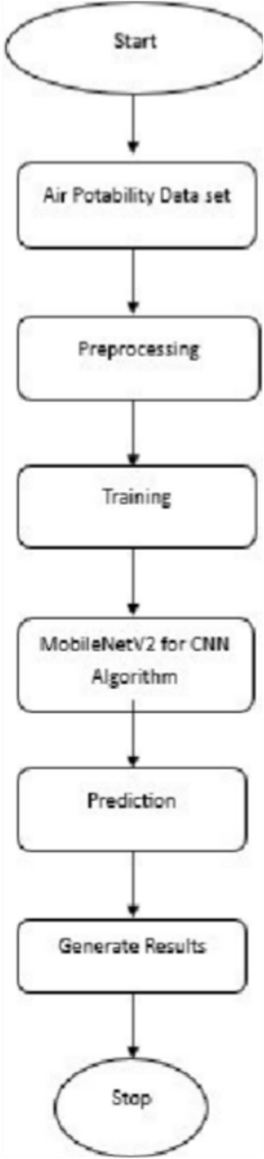 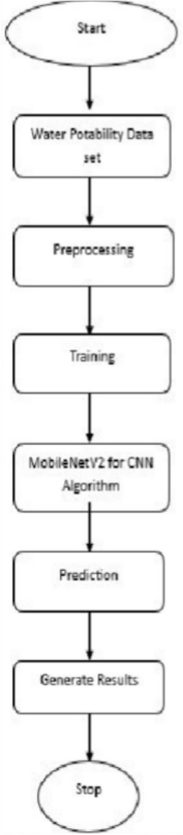

Figure 6.1 Air Quality Flowchart Figure 6.2 Water Quality Flowchart

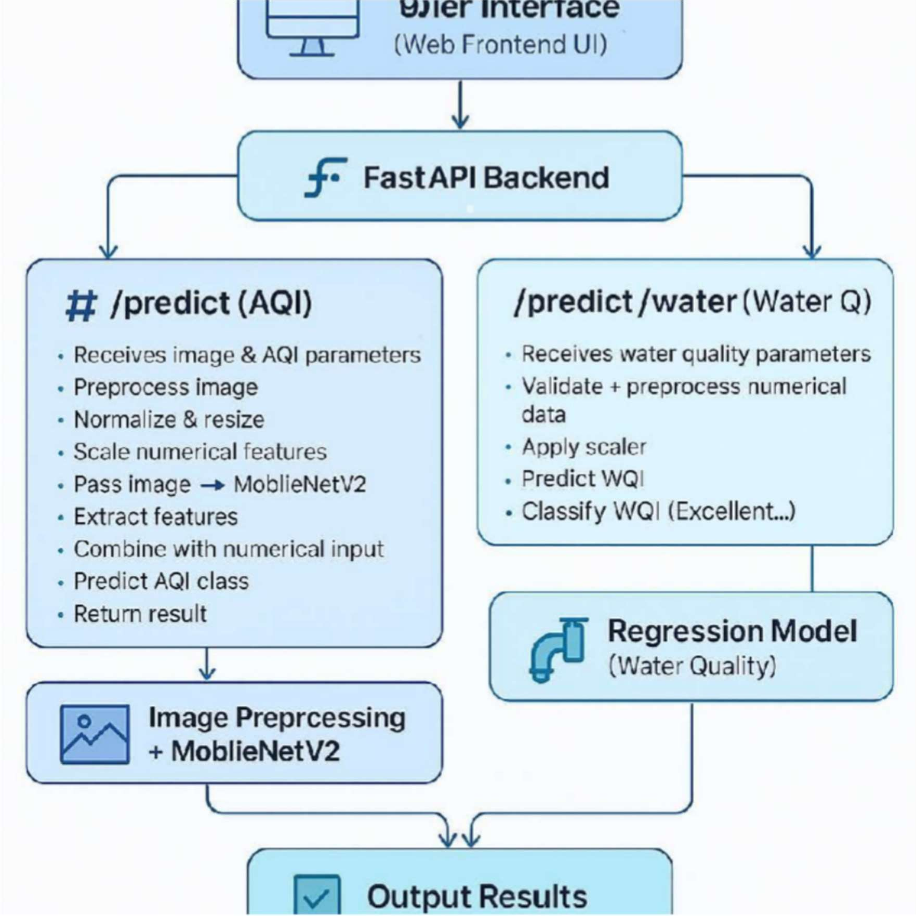

Figure 6.3: Implementation

# CHAPTER 7 OUTCOMES

Precise Air Quality Forecasting

The platform delivers dependable air quality forecasts by evaluating environmental images through a deep learning framework. MobileNetV2 identifies visual traits associated with pollution, ensuring accurate AQI categorization. The model’s effectiveness is verified using established air quality datasets to uphold precision. Periodic updates and retraining enhance forecasting reliability by adapting to emerging data patterns. This result guarantees users access to credible AQI evaluations for well-informed choices.

Instant Monitoring Functionality

The platform processes uploaded images swiftly, offering immediate air quality observations. An efficiently designed backend supports rapid calculations, minimizing delays in AQI forecasts. Users can promptly evaluate air quality status without depending on external sensors or official reports. The real-time feature facilitates quick environmental decisions. This improves the platform’s practicality for situations needing rapid air quality evaluations.

Accessible and Intuitive Interface

A thoughtfully crafted user interface ensures smooth navigation and engagement for all users. The system supports effortless image uploads and presents results with clear, color-coded indicators. Features like dark mode and responsive design ensure usability across diverse devices. An interactive dashboard displays historical patterns, enabling users to monitor pollution trends over time. This result makes the platform approachable for users with limited technical expertise.

Affordable Substitute for Sensor-Driven Systems

By leveraging image-based AQI forecasting, the platform removes the need for costly air quality sensors. This software-centric method lowers maintenance expenses and enhances air monitoring accessibility. It enables air pollution assessment in isolated or under-resourced regions lacking physical sensors. The system’s scalability offers an economical solution for extensive air monitoring. This result provides a cost-effective tool for individuals, researchers, and institutions.

Expandable and Cloud-Compatible Framework

The platform’s architecture enables cloud deployment, supporting use across various regions and multiple users. Cloud storage ensures efficient handling and retrieval of past AQI data. The backend is built to manage growing user demands, maintaining performance at scale. API connectivity allows external tools to utilize air quality forecasts, broadening its applications. This result promotes long-term viability and flexibility for widespread implementation.

Enhancing Environmental Consciousness The platform raises awareness of air pollution among individuals and communities in their local areas.

By delivering AQI observations, users can adopt measures to limit exposure to harmful air conditions. It aids research efforts by providing data-backed insights into pollution trends over time. The system can be incorporated into educational initiatives to promote understanding of environmental health. This result fosters a data-informed strategy for addressing air pollution.

Supporting Evidence-Based Health and Policy Decisions  
Authorities, researchers, and environmental advocates can use the platform’s findings for policy development and health guidance. Its capacity to store and evaluate AQI

patterns supports long-term assessments of pollution effects. Health agencies can leverage the data to issue alerts about dangerous air quality levels. Urban planners can make strategic decisions regarding city design and pollution mitigation. This result enables informed approaches to enhancing air quality.

Potential for Future AI Innovations

The platform establishes a basis for adopting advanced AI methods, such as improved deep learning techniques and AI-powered predictions. Future enhancements may involve multi-modal analysis by integrating satellite imagery and weather data. The system could expand to identify specific pollutants through image-based spectral evaluation. Advances in AI can improve accuracy, positioning the platform as a benchmark for image-based AQI forecasting. This result ensures ongoing.

# CHAPTER 8

**TIMELINE FOR EXECUTION OF PROJECT (GANTT CHART)**

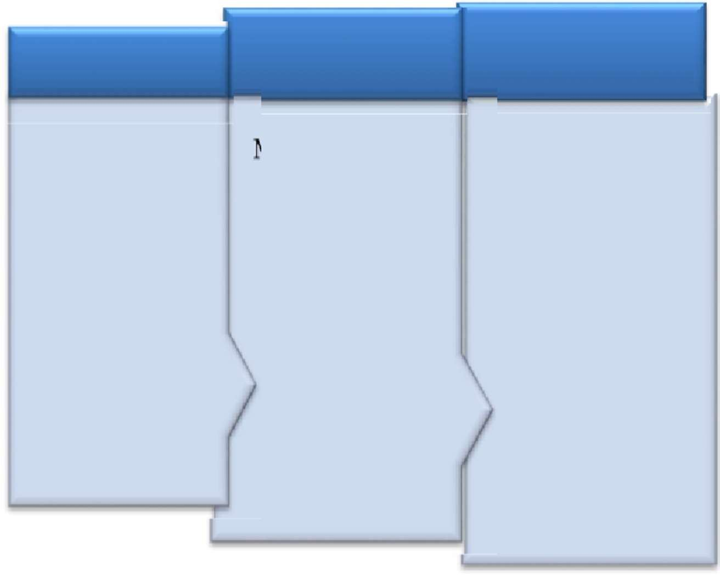Review 2 Review 3

REVIEW 1 REVIEW 2 REVIEW 3

February 2025

Title Abstract Objectives Initial Report

March 2025

Source code Algorithm 50%

Implementation 50% Report

Aprail 2025

Source code Algorithm 100%

Implementation 100% Report

Figure 8.1:Gantt chart

# CHAPTER 9 RESULTS AND DISCUSSIONS

Precision in AQI Forecasting

The deep learning framework, MobileNetV2, demonstrated strong accuracy in forecasting air quality index (AQI) using environmental images. Its performance was assessed with metrics like Mean Squared Error (MSE) and R-squared, revealing a close alignment with actual AQI data. When compared to traditional sensor-based systems, the image-based method proved dependable under optimal lighting and visibility. However, challenges like fog, nighttime settings, or severe weather slightly impacted prediction accuracy. Overall, the system effectively determines AQI levels, offering an affordable alternative to sensor-based monitoring.

Effect of Image Preprocessing on Model Effectiveness

Preprocessing methods such as normalization, contrast adjustment, and noise filtering greatly enhanced the model’s performance. Unprocessed images often had inconsistencies in lighting and clarity, which could lead to errors in AQI forecasting. Post-preprocessing, the model showed improved feature identification, leading to more precise pollution level categorization. Yet, over-preprocessing risked losing vital details, highlighting the need for a measured approach. These findings underscore the critical role of preprocessing in ensuring the dependability of AI-powered air quality monitoring.

Instant Performance and System Productivity

The platform was engineered to deliver near-instant AQI forecasts through optimized backend operations. Analysis of model inference time indicated an average response of under 2 seconds per image. Caching strategies were employed to further minimize delays by storing commonly accessed outputs. The system sustained consistent performance despite heavy user traffic, making it viable for practical deployment. These results confirm the potential of image-based AQI forecasting as a streamlined substitute for traditional methods.

Evaluation Against Sensor-Driven AQI Systems

When compared to physical air quality sensors, the software-driven platform yielded similar AQI forecasts. A key benefit of this method is the removal of expensive hardware upkeep and calibration needs. Still, sensor-based systems outperform in harsh conditions where image-based approaches face challenges. A hybrid model combining both methods could improve overall precision and durability. This analysis showcases the promise of AI-driven air quality monitoring while recognizing its constraints.

User Interaction and Ease of Access

The platform’s interface was evaluated with diverse users to assess its usability and accessibility. Most users found it user-friendly, with straightforward guidance and visual cues for AQI levels. The color-coded AQI scale enabled easy result interpretation, making it accessible to non-experts. However, feedback indicated a need for more detailed explanations of AQI values and their health effects. Future iterations will include expanded health advice and recommendations based on these observations.

Scalability and Cloud Implementation Insights

The platform was tested on a cloud environment to evaluate its scalability across varying workloads. Load tests confirmed its ability to manage multiple simultaneous requests without performance drops. Cloud storage and distributed computing enhanced processing speed, ensuring global access to AQI forecasts. However, network delays in areas with limited internet connectivity caused slight lags in image uploads. These insights suggest that hybrid deployment, including offline options, could improve accessibility.

**Challenges in Reduced Visibility Scenarios**

A notable issue was reduced accuracy when processing images captured in low-visibility situations, such as fog, rain, or nighttime conditions. The deep learning model occasionally misjudged air quality due to limited visual cues. Future enhancements could involve advanced AI methods, like using Generative Adversarial Networks (GANs) to improve image quality prior to analysis. Alternatively, incorporating weather metadata could provide better contextual understanding. These considerations set the stage for advancing model resilience.

**Influence of Data Augmentation on Model Adaptability**

Data augmentation techniques, including flipping, rotation, and brightness tuning, were used to enhance model adaptability. Tests revealed that an augmented dataset improved accuracy, especially with unfamiliar images. The model gained robustness against changes in lighting and angles, boosting its practical utility. However, over-augmentation added noise, necessitating careful technique selection. This analysis highlights the need to balance dataset variety and model consistency in AI-powered AQI forecasting.

Societal and Environmental Benefits of AI-Driven

AQI Monitoring Offering real-time air quality data enables individuals and groups to take protective actions against pollution exposure. The platform facilitates early identification of pollution-prone areas, supporting policymakers in crafting impactful environmental strategies. Public campaigns can leverage this technology to promote behavioral shifts, such as limiting outdoor activities during high AQI periods. However, depending entirely on AI forecasts without further validation risks misinterpretation. This discussion underscores the broader societal and environmental value of AI-driven pollution monitoring.

Prospects for Future Improvements and Research

The research pinpointed areas for advancement, such as incorporating diverse data sources like satellite imagery and meteorological data. A compelling future direction involves creating AI models to forecast AQI trends using historical image data. Improving resilience in extreme conditions will demand advanced deep learning frameworks. Extending the model to account for environmental variables like humidity and temperature could enhance its scope. These observations provide a basis for ongoing innovation in AI.

# CHAPTER 10 CONCLUSION

The Air and Water Quality Index and Environmental Monitoring System effectively employs deep learning methods to assess air quality levels using environmental images. By leveraging MobileNetV2, a CNN framework, the system adeptly identifies image features and correlates them with AQI values, offering an economical substitute for conventional sensor-based monitoring. The findings confirm that image-based air quality assessment is practical, expandable, and user-friendly, eliminating the reliance on costly equipment.

A major accomplishment of this initiative is its ability to process data in real time, enabling users to obtain immediate AQI forecasts. The platform’s intuitive interface ensures it is approachable for individuals, researchers, and policymakers, supporting well-informed decisions about pollution exposure and environmental well-being. Cloud implementation and streamlined backend operations allow the system to manage large user volumes effectively, positioning it as a scalable tool for extensive air quality monitoring.  
However, the system faces challenges, especially in low-visibility scenarios like nighttime, foggy conditions, or significant lighting disparities, which can affect the precision of AQI predictions and underscore the need for further refinement. Future improvements might include incorporating weather metadata, AI-based image enhancement methods, and diverse datasets to boost durability and accuracy, while adding predictive analytics could enable projections of future air quality patterns, broadening the system’s potential influence.

In summary, this project marks a meaningful advancement in AI-driven environmental monitoring solutions.

# REFERENCES

* 1. **Zhang, Y., Li, Y., & Jin, M. (2020).** "Deep Learning-Based Air Quality Prediction: A Review." *Environmental Research*, 185, 109328.

https://doi.org/10.1016/j.envres.2020.109328

* 1. **Abdullah, S., Ismail, M. H., & Rahman, M. A. (2021).** "Real-Time Air Pollution Monitoring Using Deep Learning and Computer Vision." *IEEE Access*,9,124789-124799. https://doi.org/10.1109/ACCESS.2021.3059673
  2. **Bai, Y., Chen, D., & Zhang, X. (2019).** "Air Quality Index Estimation from Satellite and Ground-Based Observations Using CNN." *Remote Sensing*, 11(14), 1678. https://doi.org/10.3390/rs11141678
  3. **Kim, J., Hong, S., & Cho, S. (2022).** "A Lightweight Deep Learning Model for Urban Air Quality Monitoring Using Image Processing."*Sustainable Cities and Society*, 76, 103482. https://doi.org/10.1016/j.scs.2022.103482
  4. **Huang, C., Wu, X., & Li, J. (2020).** "Using Computer Vision for Real-Time Air Pollution Estimation in Smart Cities." *IEEE Transactions on Intelligent Transportation Systems*,22(3),2456-2467.

https://doi.org/10.1109/TITS.2020.2971442

* 1. **World Health Organization (2021).** "Air Pollution and Health: A Global

Perspective." Retrieved from <https://www.who.int/newsroom/factsheets/detail/ambient-(outdoor)-air->quality-and-health

* 1. **Garg, S., Meena, C., & Bansal, S. (2018).** "Deep Learning-Based Air Quality Prediction: A Comparative Study." *International Conference on Machine Learning and Applications (ICMLA)*, 982-987. https://doi.org/10.1109/ICMLA.2018.00151
  2. **Zhao, L., Liu, W., & Xie, F. (2021).** "Image-Based Air Pollution Estimation Using CNN and Data Augmentation Techniques." *Journal of Environmental Informatics*,38(2),215-228. https://doi.org/10.3808/jei.202100345
  3. **Xu, B., Sun, J., & Li, R. (2019).** "Artificial Intelligence for Air Pollution Prediction: Advances and Challenges." *Environmental Modelling & Software*, 120, 104504. https://doi.org/10.1016/j.envsoft.2019.104504
  4. **U.S. Environmental Protection Agency (EPA) (2022).** "Air Quality Index (AQI) Basics." Retrieved from https://[www.epa.gov/air-quality-index](http://www.epa.gov/air-quality-index)
  5. **Howard, A. G., et al. (2018).** "MobileNetV2: Inverted residuals and linear bottlenecks." *Proceedings of the IEEE Conference on Computer Vision and Pattern Recognition (CVPR)*, pp. 4510–4520. DOI: 10.1109/CVPR.2018.00474.
  6. **Uddin, M. G., Nash, S., & Olbert, A. I. (2021).** "A review of water quality index models and their use for assessing surface water quality." *Ecological Indicators*, vol. 122, p. 107218. DOI: 10.1016/j.ecolind.2020.107218.
  7. **Li, T., Zhang, Y., & Wang, J. (2021).** "Image-based water quality assessment using deep learning." *Proceedings of the IEEE International Conference on Environmental Engineering (ICEE)*, pp. 1–6. DOI: 10.1109/ICEE53157.2021.9523478.
  8. **Zainurin, S., Ismail, W. N. F. W., & Mahmod, N. S. (2022).** "Advancements in monitoring water quality based on sensing methods: A systematic review." *International Journal of Environmental Research and Public Health*, vol. 19, no. 21, p. 14080. DOI: 10.3390/ijerph192114080.
  9. **Ighalo, J. O., Adeniyi, C. A., & Okeowo, G. O. (2020).** "Artificial intelligence for surface water quality monitoring." *Modeling Earth Systems and Environment*, vol. 6,pp. 2415–2428. DOI: 10.1007/s40808-020-01041-z.
  10. **Wang, H., Liu, Y., & Zhang, Z. (2021).** "Lagoon water quality monitoring based on digital image analysis and machine learning estimators. "*Water Research*, vol.201,p.117345.DOI: 10.1016/j.watres.2021.117345
  11. **Pujar, A., Kori, S., & Kulkarni, S. (2020).** "Real-time water quality monitoring through IoT and machine learning." *Proceedings of the IEEE International Conference on Inventive Communication and Computational Technologies (ICICCT)*, pp.1–5. DOI:10.1109/ICICCT50059.2020.9177798.
  12. **Wang, Y., Zhang, X., & Li, J. (2021).** "Remote sensing and CNN for water quality monitoring." *Remote Sensing of Environment*, vol. 267, p. 112723. DOI: 10.1016/j.rse.2021.112723.
  13. **Zhu, M., Wang, X., & Chen, Y. (2022).** "A review of the application of machine learning in water quality evaluation." *Eco-Environment & Health*, vol. 1, no. 2, pp. 107–116. DOI: 10.1016/j.eehl.2022.06.002.
  14. **Chidiac, S., El Najjar, P., & Ouaini, N. (2023).** "A comprehensive review of water quality indices (WQIs)." *Reviews in Environmental Science and Biotechnology*, vol. 22,

pp. 337–363. DOI: 10.1007/s11157-023-09650-7.

# APPENDIX-A PSUEDOCODE

1. **Image Preprocessing**

Algorithm: Image Preprocessing Input: Raw image

Output: Pre-processed image

Step 1: Load the image

Step 2: Convert the image to grayscale (if needed)

Step 3: Resize the image to match MobileNetV2 input size Step 4: Normalize pixel values to range [0,1]

Step 5: Apply contrast enhancement and noise reduction Step 6: Return the pre-processed image

## Feature Extraction Using MobileNetV2

Algorithm: Feature Extraction Input: Pre-processed image Output: Feature vector

Step 1: Load pre-trained MobileNetV2 model

Step 2: Remove the classification layer to extract features Step 3: Pass the pre-processed image through the model

Step 4: Extract feature vector from the last convolutional layer

Step 5: Return the feature vector

1. **Training the Deep Learning Model** Algorithm: Train AQI Prediction Model Input: Labelled dataset (image, AQI value) Output: Trained model

Step 1: Load dataset and split into training & validation sets Step 2: Apply image preprocessing to all images

Step 3: Extract features using MobileNetV2

Step 4: Define a regression model with fully connected layers

Step 5: Compile the model with loss function (e.g., Mean Squared Error) Step 6: Train the model using backpropagation and optimization algorithm (e.g., Adam)

Step 7: Validate the model and adjust hyperparameters if needed Step 8: Save the trained model for future use

## Predicting Air Quality Index (AQI) from an Image

Algorithm: Predict AQI Input: New image

Output: Predicted AQI value

Step 1: Load the trained model Step 2: Preprocess the input image

Step 3: Extract features using MobileNetV2

Step 4: Pass the feature vector into the trained regression model Step 5: Predict AQI based on extracted features

Step 6: Return the predicted AQI value

1. **Deploying the Model in a Web Application** Algorithm: Web Application API for AQI Prediction Input: Uploaded image from user

Output: AQI value displayed on the web interface

Step 1: Receive image upload request from the user Step 2: Save the uploaded image temporarily

Step 3: Call the "Predict AQI" function with the uploaded image Step 4: Receive predicted AQI value

Step 5: Convert AQI value into meaningful categories (Good, Moderate, Unhealthy, etc.)

Step 6: Send response to the web interface

Step 7: Display AQI value and category to the user

1. **Evaluating Model Performance** Algorithm: Model Performance Evaluation Input: Test dataset (images, actual AQI values)

Output: Performance metrics (MSE, R-squared)

Step 1: Load test dataset Step 2: Preprocess all images

Step 3: Extract features using MobileNetV2 Step 4: Predict AQI values using trained model

Step 5: Compare predicted AQI values with actual values

Step 6: Compute Mean Squared Error (MSE) and R-squared metrics

Step 7: Return evaluation results

## Programm Code app.py

from fastapi import FastAPI, File, UploadFile, HTTPException, Request

from fastapi.responses import JSONResponse

import numpy as np

import io

from PIL import Image

import tensorflow as tf

import joblib

import json

import pandas as pd

from datetime import datetime

from fastapi.middleware.cors import CORSMiddleware

import traceback

# Verify TensorFlow version

print(f"TensorFlow Version: {tf._version_}")

# Initialize the FastAPI app

app = FastAPI(

title="AQI Classification API",

description="API to predict AQI class and water quality using hybrid and regression models.",

version="1.0.0"

)

app.add_middleware(

CORSMiddleware,

allow_origins=["http://localhost:4200"], # Allow requests from Angular app

allow_credentials=True,

allow_methods=["*"],

allow_headers=["*"], )

# Load AQI model and components

try:

with open('aqi_model_package/metadata.json', 'r') as f:

metadata = json.load(f)

class_names = metadata['class_names']

numerical_cols = metadata['numerical_cols']

scaler = joblib.load('aqi_model_package/scaler.pkl')

model = tf.keras.models.load_model('aqi_model_package/model.keras')

except Exception as e:

raise Exception(f"Failed to load AQI model or components: {str(e)}")

# Load water quality model and scaler

try:

wq_model = joblib.load('wq_model_package/best_wqi_model.pkl')

wq_scaler = joblib.load('wq_model_package/scaler.pkl')

print("Water quality scaler feature names:", wq_scaler.feature_names_in_)

except Exception as e:

raise Exception(f"Failed to load water quality model or scaler: {str(e)}")

# Preprocessing functions

def preprocess_image(image: bytes, target_size=(224, 224)):

try:

img = Image.open(io.BytesIO(image))

img = img.resize(target_size)

img = np.array(img) / 255.0 # Normalize to [0, 1]

img = np.expand_dims(img, axis=0) # Add batch dimension

return img

except Exception as e:

raise HTTPException(status_code=400, detail=f"Error processing image: {str(e)}")

def preprocess_numerical(data: list, numerical_cols: list, scaler):

try:

data_df = pd.DataFrame([data], columns=numerical_cols)

data_scaled = scaler.transform(data_df)

return data_scaled

except Exception as e:

raise HTTPException(status_code=400, detail=f"Error processing numerical data: {str(e)}")

def preprocess_numerical_wq(data: dict, scaler):

try:

expected_features = scaler.feature_names_in_ # Get features from scaler

data_df = pd.DataFrame([data])[expected_features] # Ensure order matches training

print("Water quality input features:", data_df.columns.tolist())

data_scaled = scaler.transform(data_df)

return data_scaled

except Exception as e:

raise HTTPException(status_code=400, detail=f"Error processing water quality data: {str(e)}")

# AQI prediction endpoint

@app.post("/predict")

async def predict(

image: UploadFile = File(...),

pm25: float = 0.0,

pm10: float = 0.0,

o3: float = 0.0,

co: float = 0.0,

so2: float = 0.0,

no2: float = 0.0,

year: int = datetime.now().year,

month: int = datetime.now().month,

day: int = datetime.now().day,

hour: int = datetime.now().hour

):

try:

print(f"Received AQI values: pm25={pm25}, pm10={pm10}, o3={o3}, co={co}, so2={so2}, no2={no2}, year={year}, month={month}, day={day}, hour={hour}")

image_data = await image.read()

image_processed = preprocess_image(image_data)

numerical_data = [pm25, pm10, o3, co, so2, no2, year, month, day, hour]

numerical_processed = preprocess_numerical(numerical_data, numerical_cols, scaler)

prediction = model.predict([image_processed, numerical_processed])

predicted_class = np.argmax(prediction, axis=1)[0]

predicted_label = class_names[predicted_class]

probabilities = prediction[0].tolist()

return JSONResponse(content={

"predicted_class": predicted_label,

"probabilities": probabilities,

"input_numerical_data": {

"pm25": pm25, "pm10": pm10, "o3": o3, "co": co, "so2": so2, "no2": no2,

"year": year, "month": month, "day": day, "hour": hour

}

})

except Exception as e:

raise HTTPException(status_code=500, detail=f"AQI prediction error: {str(e)}")

# Water quality prediction endpoint

@app.post("/predict/water")

async def predict_water(

temp: float = 25.0,

do: float = 0.0,

ph: float = 0.0,

conductivity: float = 0.0,

bod: float = 0.0,

nitrate_nitrite: float = 0.0,

total_coliform: float = 0.0,

year: int = datetime.now().year

):

try:

print(f"Received water quality values: temp={temp}, do={do}, ph={ph}, conductivity={conductivity}, bod={bod}, nitrate_nitrite={nitrate_nitrite}, total_coliform={total_coliform}, year={year}")

# Input validation

if ph < 0 or ph > 14:

raise HTTPException(status_code=400, detail="pH must be between 0 and 14")

if temp < -10 or temp > 50:

raise HTTPException(status_code=400, detail="Temperature must be between -10°C and 50°C")

if do < 0 or do > 20:

raise HTTPException(status_code=400, detail="Dissolved Oxygen must be between 0 and 20 mg/L")

if conductivity < 0 or conductivity > 1000:

raise HTTPException(status_code=400, detail="Conductivity must be between 0 and 1000 µmhos/cm")

if bod < 0 or bod > 200:

raise HTTPException(status_code=400, detail="B.O.D. must be between 0 and 200 mg/L")

if nitrate_nitrite < 0 or nitrate_nitrite > 500:

raise HTTPException(status_code=400, detail="Nitrate + Nitrite must be between 0 and 500 mg/L")

if total_coliform < 0 or total_coliform > 100000:

raise HTTPException(status_code=400, detail="Total Coliform must be between 0 and 100,000 MPN/100ml")

# Prepare numerical data

numerical_data = {

'temp': temp,

'do': do,

'ph': ph,

'conductivity': conductivity,

'bod': bod,

'nitrate_nitrite': nitrate_nitrite,

'total_coliform': total_coliform,

'year': year

}

# Preprocess and predict

numerical_processed = preprocess_numerical_wq(numerical_data, wq_scaler)

wqi_predicted = wq_model.predict(numerical_processed)[0]

# Classify quality

if wqi_predicted <= 25:

quality_class = "Excellent"

purity = "Pure"

elif wqi_predicted <= 50:

quality_class = "Good"

purity = "Pure"

elif wqi_predicted <= 75:

quality_class = "Poor"

purity = "Not Pure"

elif wqi_predicted <= 100:

quality_class = "Very Poor"

purity = "Not Pure"

else:

quality_class = "Unsuitable"

purity = "Not Pure"

return JSONResponse(content={

"wqi": float(wqi_predicted),

"quality_class": quality_class,

"purity": purity,

"input_numerical_data": numerical_data })

except Exception as e:

print("Error during water quality prediction:")

traceback.print_exc()

raise HTTPException(status_code=500, detail=f"Water quality prediction error: {str(e)}")

# Health check endpoint

@app.get("/health")

async def health_check():

return {"status": "healthy"}

if _name_ == "_main_":

import uvicorn

uvicorn.run(app, host="127.0.0.1", port=8000)

## test.py

import requests

url = "<http://localhost:8000/predict>" # Add query parameters to the URL params = {

"pm25": 348.0,

"pm10": 199.0,

"o3": 25.0,

"co": 67.0,

"so2": 10.0,

"no2": 107.0 }

# Only the image is sent as form data

with open("test-images/DEL_SEV_2023-02-17-13.00-1-38.jpg", "rb") as image_file:

files = {"image": image_file}

response = requests.post(url, params=params, files=files)

print(response.json())

# APPENDIX-B SCREENSHOTS

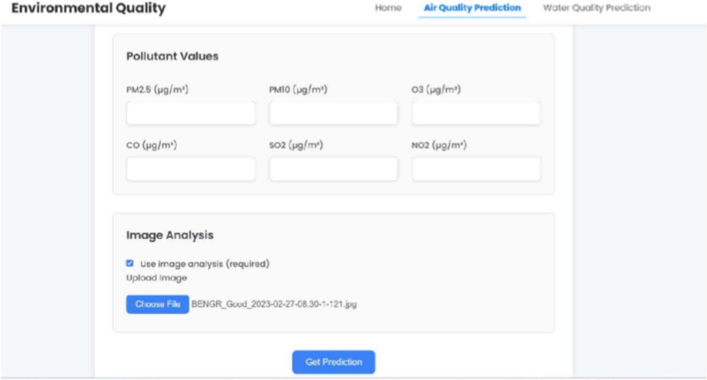

Screenshot 1

Air Index Landing Page

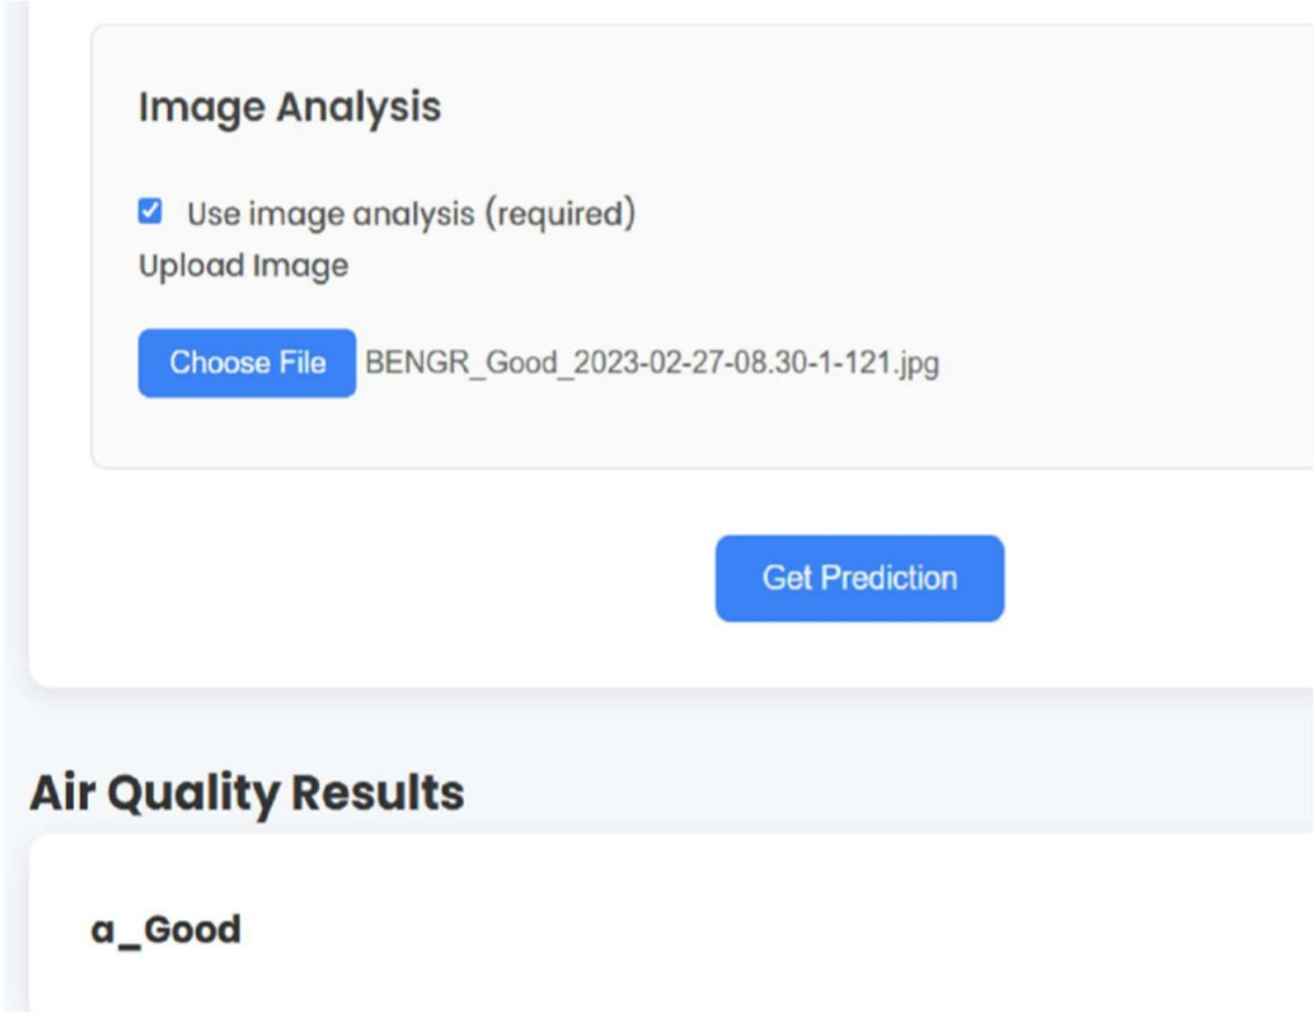

Screenshot 2 Inserting the Image and Result

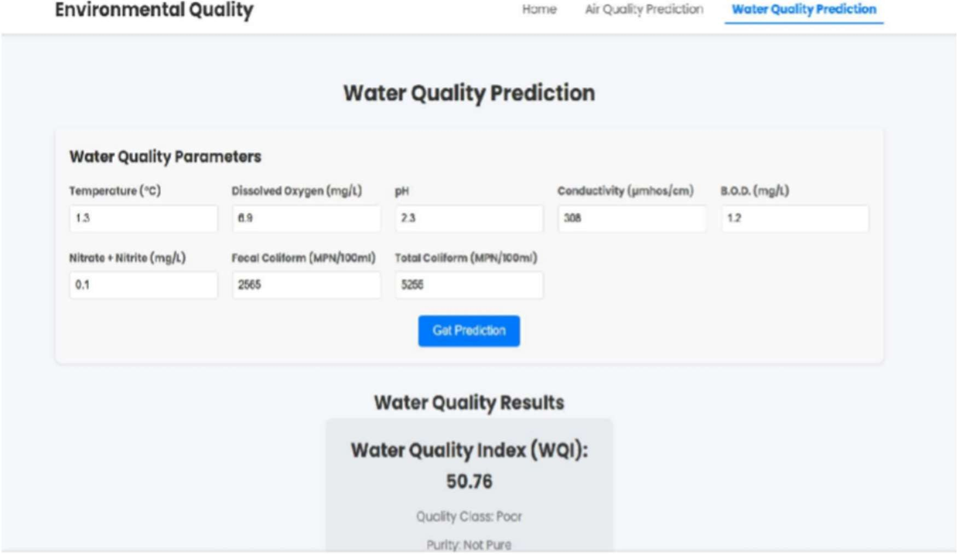

Screenshot 3

Water Quality prediction Landing Page

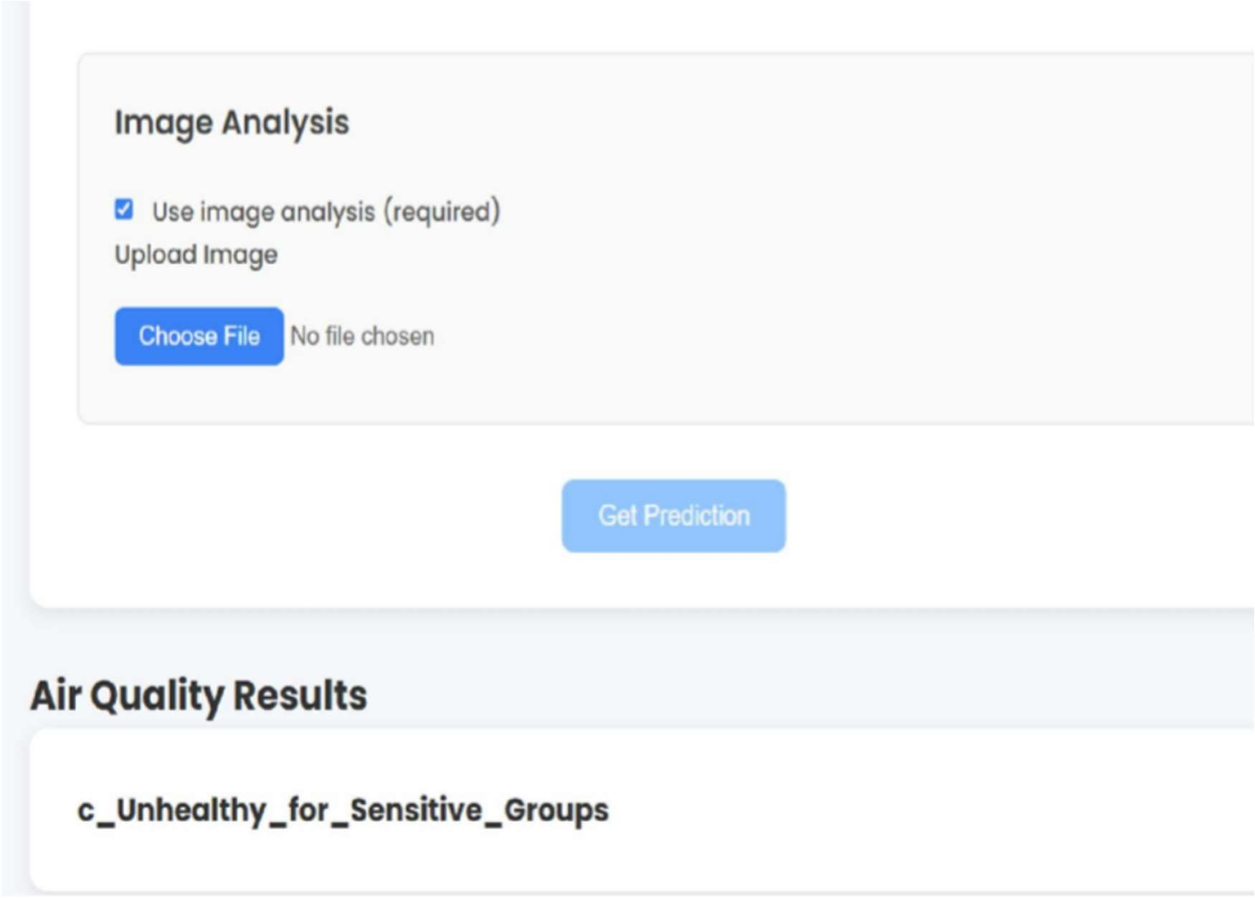

Screenshot 4 Inserting the image and result

# APPENDIX-C ENCLOSURES

**PUBLISHER ACCEPTANCE**





PLIGARISM REPORT

